**SECTION I – MULTIPLE CHOICE** 10 marks – each question is of equal value

*Enter solutions on the MULTIPLE CHOICE ANSWER SHEET provided*

|  |  |  |  |
| --- | --- | --- | --- |
| 1. The diagram below shows the graph of  and . | | | |
|  | | | |
| What is the area between the curves  and ? | | | |
|  | | (A) 4.5 units2 | |
|  | | (B) 5.5 units2 | |
|  | | (C) 9.0 units2 | |
|  | | (D) 13.5 units2 | |
| 1. Which of the following is equal to? 2. – 1 3. A and B are the points (4 , 8) and (12 , 10). The distance of AB is 5. 68 6. 60   **4** Which of the following is the simplification of $\frac{a^{3}-8}{3a-6}$? $\frac{a^{2}-2a+4}{3}$ $\frac{a^{2}+2a+4}{3}$ $\frac{a+2}{a-2}$ $\frac{a^{2}-4}{3}$  **5** If $\frac{7}{3\sqrt{2}-2}=p+q\sqrt{2}$, which of the following statements is true? $p=1$ $q=\frac{21}{32}$ $p=\frac{7}{8}$ $q=-\frac{9}{14}$  **6** Which of the following equations describes the locus of all points with vertex (-2 , -2)  and directrix $y=2$. ${\left(x+2\right)}^{2}=-16(y+2)$ ${\left(x-2\right)}^{2}=-8\left(y-2\right)$ ${\left(y+2\right)}^{2}=-8\left(x+2\right)$ ${\left(y-2\right)}^{2}=4\left(x-2\right)$     **7** If $\sin{x= \frac{12}{13}}$ and $\cos{x <0}$, which of the following is a correct statement? $\cos{x= \frac{12}{13}}$ $cosec x= -\frac{13}{12}$ $tanx=-\frac{5}{12}$ $\sec{x= -\frac{5}{13}}$     **8** Which of the following represents the domain of $=\sqrt{\frac{x+2}{x-2}}$? $\left\{x:-2≤x≤2\right\}$ $\left\{x:x≠2\right\}$ $\left\{x:-2≤x<2\right\}$ $\left\{x:x<-2 or x>2\right\}$     **9** | |
|  | |

Which of the following pairs of inequalities could describe the shaded region in the diagram above?

1. $y≥2^{-x}-1$ and $y≤x^{3}-1$
2. $y≤1-2^{x}$ and $y≥ x^{3}-1$
3. $y≤2^{x}-2$ and $y≤ {\left(x+1\right)}^{3}$
4. $y≥2^{-x}-1$ and $y≥{\left(x-1\right)}^{3}$

**10** In the diagram, ABC is a triangle where AC = 6m, CB = 4m and $∠ACB={120}^{o}$.

A

C

B

1200

6 m

4 m

NOT TO SCALE

The distance of AB is

1. 16 (B) 76 (C) $2\sqrt{19}$ (D) 36

**SECTION II**

**QUESTION 11** 14 marks – allocation of marks as shown

|  |  |  |  |
| --- | --- | --- | --- |
| (a) | Solve . | | **2** |
| (b) | Evaluate. | | **2** |
| (c) | The gradient of the curve is given by . The curve passes through . Find the equation of the curve. | | **2** |
| (d) | Find the value of *p* if the points A(2 , 5), B(3 , *p*) and C(4 , 11) are collinear. | | **2** |
| (e) | In the diagram above, $A\left(-2 , 0\right), B\left(-13 , 8\right)$ and $C(0 , 4)$. | |  |
|  | (i) | Find the gradient of *AC*. | **1** |
|  | (ii) | Hence find the angle of inclination of *AC (answer to nearest minute)*. | **1** |
|  | (iii) | Find the equation of line *AC*. | **2** |
|  | (iv) | Find point *M*, the midpoint of *AC* and hence show that *MB* is perpendicular to *AC*. | **2** |

*Start this question in a SEPARATE booklet*  **Marks**

**QUESTION 12**  10 marks – allocation of marks as shown

*Start this question in a SEPARATE booklet* **Marks**

1. Five values of the function $y=f\left(x\right)$ are shown in the table below. **2**

|  |  |  |  |  |  |
| --- | --- | --- | --- | --- | --- |
| *x* | 0 | 2 | 4 | 8 | 16 |
| *f(x)* | 1 | 4 | 8 | 14 | 25 |

Using the table (5 ordinates) and the Simpsons Rule, evaluate $\int_{0}^{16}{f\left(x\right) dx}$.

1. For what values of *k* does the quadratic $kx^{2}+\left(2k-3\right)x+2=0$ have real roots. **3**
2. Find the equation of the directrix for the parabola $x^{2}=16y$**2**
3. If $α$ and β are the roots of $3x^{2}+5x-6=0$, find the value of $\frac{1}{α}+ \frac{1}{β}$**3**

**QUESTION 13**  15 marks – allocation of marks as shown

*Start this question in a SEPARATE booklet* **Marks**

1. For the curve $y=\frac{x^{3}}{3}-3x^{2}+8x+5$

(i) Find the coordinates of the stationary points, and determine their nature. **3**

(ii) Find the point of inflexion and show that it is the midpoint of the stationary points. **2**

(iii) Sketch the curve, showing all necessary information **2**

(b)

*x*

*y*

0

*A*

*B*

**

**

5

NOT TO SCALE

The shaded region *OAB* is bounded by the parabolas , and the *x*-axis.

Point *A* is the intersection of the two parabolas and point *B* is the *x*-intercept of the

parabola **.

(i) Find the *x* components (ordinate values) of points *A* and *B*. **2**

(ii) Show that the exact area of the shaded region *OAB* is given by

 square units. **4**

(c) Differentiate with respect to *x.* **2**

${\frac{d}{dx}\left(e^{x}+1\right)}^{3}$

**QUESTION 14**  14 marks – allocation of marks as shown

*Start this question in a SEPARATE booklet* **Marks**

1. If $y=\frac{2x-1}{2x+1}$
2. Show that $\frac{dy}{dx}=\frac{4}{{\left(2x+1\right)}^{2}}$**1**
3. Find the equation of the normal to this curve at the point $P\left(\frac{1}{2} , 0\right)$**2**
4. Find the coordinates of *Q*, the other point on this curve where the tangent

is parallel to the tangent at *P*. **2**

1. In the diagram below, *AB* is parallel to *CD* and ∠*BDC* = ∠*ACD* = αo.

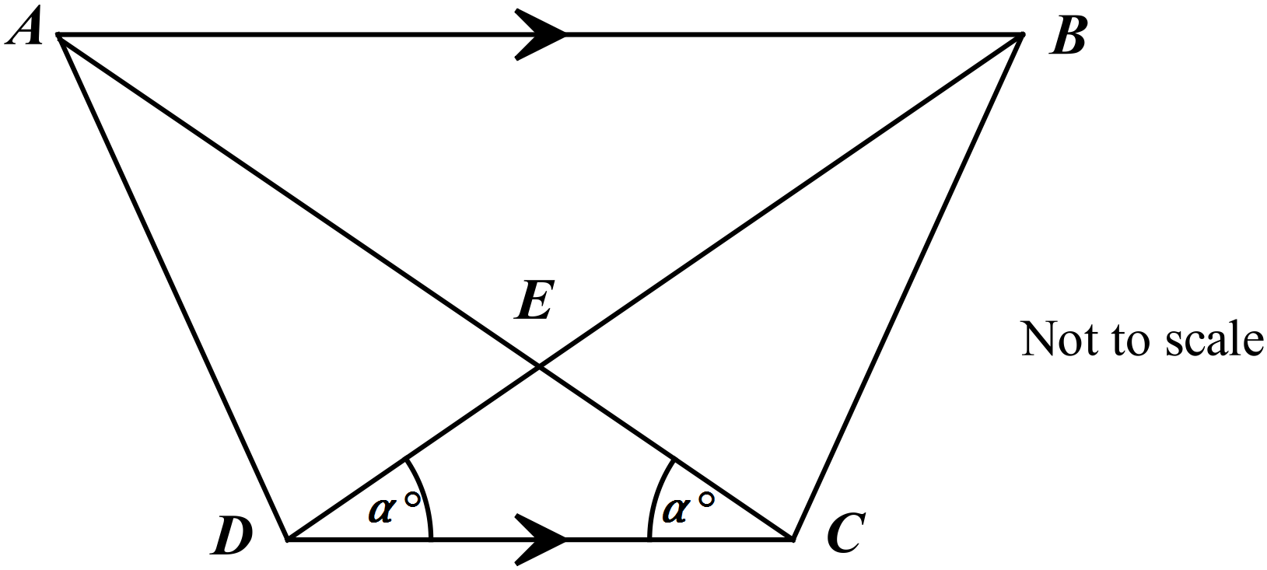

1. Show that *AE* = *EB*  **1**
2. Prove that Δ*ACD $≡ Δ$ BCD* **2**
3. Hence prove that ∠*ADE* = ∠*BCE* **1**
4. Graph the region bounded by $x^{2}+y^{2}<4$ and $y≤x^{2}+1$. **3**
5. Solve $\left|3x-2\right|≤1$**2**

**QUESTION 15**  12 marks – allocation of marks as shown

*Start this question in a SEPARATE booklet* **Marks**

1. A rainwater tank is to be designed in the shape of a cylinder with radius *r* metres and the height *h* metres. The volume of the tank is the be 10m3. Let *A* be the surface area of the tank including its top and base in m2.
2. Given that $A=2πr^{2}+2πrh$, show that $A=2πr^{2}+\frac{20}{r}$**2**
3. Show that *A* has a minimum value and find the value of *r* for which the

minimum occurs. **3**

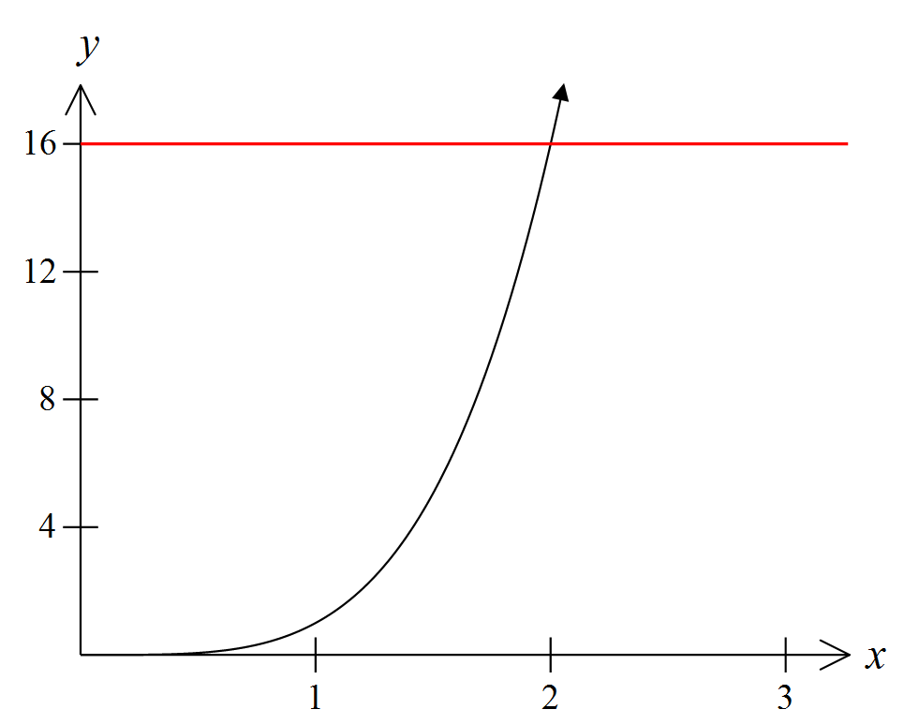

A region in the diagram is bounded by the curve , the *x*-axis and the line .

Find the volume of the solid of revolution when this region is rotated about the *y*-axis? **3**

1. Differentiate $x^{2}e^{x}$**2**
2. Find $\int{e^{4x+1}}dx$**2**

**END OF SECTION II**

**END OF ASSESSMENT**